Blueberry Muffins
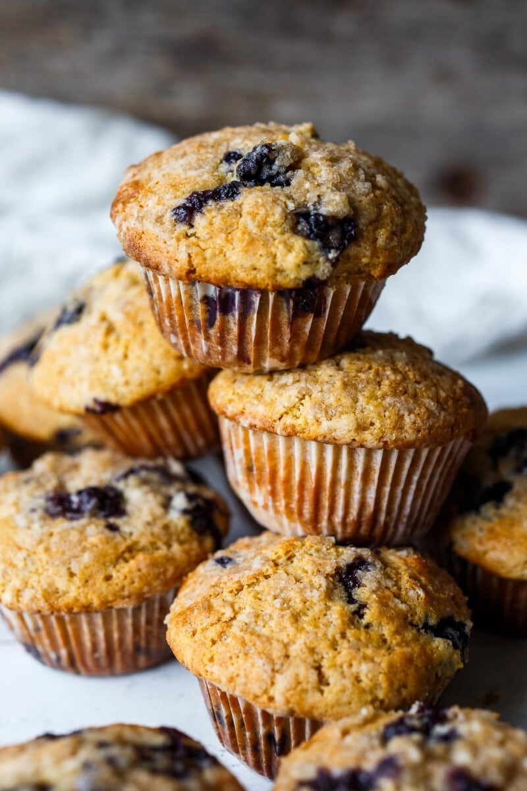
DESCRIPTION:
Tender Blueberry Muffins lightly sweetened, enhanced with lemon zest, vanilla and cardamom made with fresh or frozen blueberries. A delicious breakfast or afternoon snack. Gluten-free adaptable.

INGREDIENTS:
2 1/2 cups (300 grams) ww pastry flour (use all purpose or 1/2 wheat 1/2 white)
1/2 to 3/4 cup (100 to 150 grams) sugar (see notes)
2 teaspoons baking powder
1/2 teaspoon baking soda
2 teaspoon cardamom (optional or use 1 teaspoon cinnamon)
1/2 teaspoon salt
2/3 cup (80 ml) olive oil (or a more neutral oil if preferred)
2 eggs, room temperature
1 cup (414 ml) Greek yogurt
2 teaspoons vanilla
1/4 cup (59 ml) milk (plant based is fine if preferred)
2 teaspoons lemon zest
1 1/2 cups (220 grams) blueberries, fresh or frozen (do not thaw-*see notes)
Streusel Topping (optional- but makes them special!)
1/4 cup flour (use a gluten free blend if desired)
1/4 cup sugar, coarse or regular
2 tablespoons coconut oil or butter
pinch of salt
pinch of cardamom
Cook Mode Prevent your screen from going dark
INSTRUCTIONS:
Heat the oven to 375F degrees. Oil or line a 12 hole muffin tin with papers (oil the papers!)
(Optional)Mix streusel: Mix together the streusel by mixing together the flour, sugar, salt and mash the butter in until in forms a coarse crumb. Pop it in the freezer while you make the muffin batter.
Dry ingredients: Measure out flour, sugar, baking powder, baking soda, cardamom (if using), and salt. Stir together.
Wet ingredients: In a separate bowl whisk together thoroughly olive oil, eggs, Greek yogurt, vanilla, milk, and lemon zest.
Combine: Add the wet ingredients into the dry and gently mix until mostly incorporated. Avoid over mixing! Add the blueberries, folding in just enough to distribute.
Fill: Scoop batter into the muffin tin, a mechanical ice cream scoop works great for this. Fill up to the top. Press a few blueberries into the top of each muffin. Sprinkle about 1 teaspoon of the streusel over the top of each muffin.
Bake for 20-25 minutes or until they bounce back when pressed in the center or around 200F degrees, internally, on a thermometer. Remove the muffins from the tin and let them cool on a rack.

NUTRITION:
Serving Size: 1 muffin (without streusel topping)
Calories: 261Sugar: 11.1 g
Sodium: 125.6 mg
Fat: 14 g
Saturated Fat: 2.2 g
Carbohydrates: 31 g
Fiber: 3.3 g
Protein: 6.1 g
Cholesterol: 31.8 mg

